Cromarty Tennis & Sports Club’s
Free Tennis Coaching
Delivered by
Inverness Tennis Academy Coaches
Starting Monday 7th September
Then every Monday until 5th October
At the Cromarty Tennis Courts
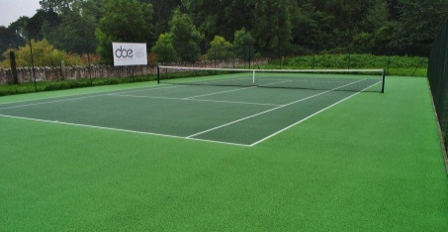

P2 - P5 3:30pm – 4:30pm
P1 - 4:30pm – 5pm
P6 – S3 5pm- 6pm
Adults 6pm – 7pm
1 hr private lesson with the coach 7pm - 8pm
There are 5 private lessons available, if you would like one of the private lessons you must book in advance, can be a group booking if you wish.
Your coach will be Scott.
To register, phone Vicky on 01381600412 or 07810046323

